**Ideation Phase**

**Intelligent garbage classification & Idea Prioritization Template**

|  |  |
| --- | --- |
| Date | 05 september2023 |
| Team ID | NM2023TMID19094 |
| Project Name | Intelligent garbage classification using deep learning |
| Maximum Marks | 4 Marks |

**Intelligent garbage classification & Idea Prioritization Template:**

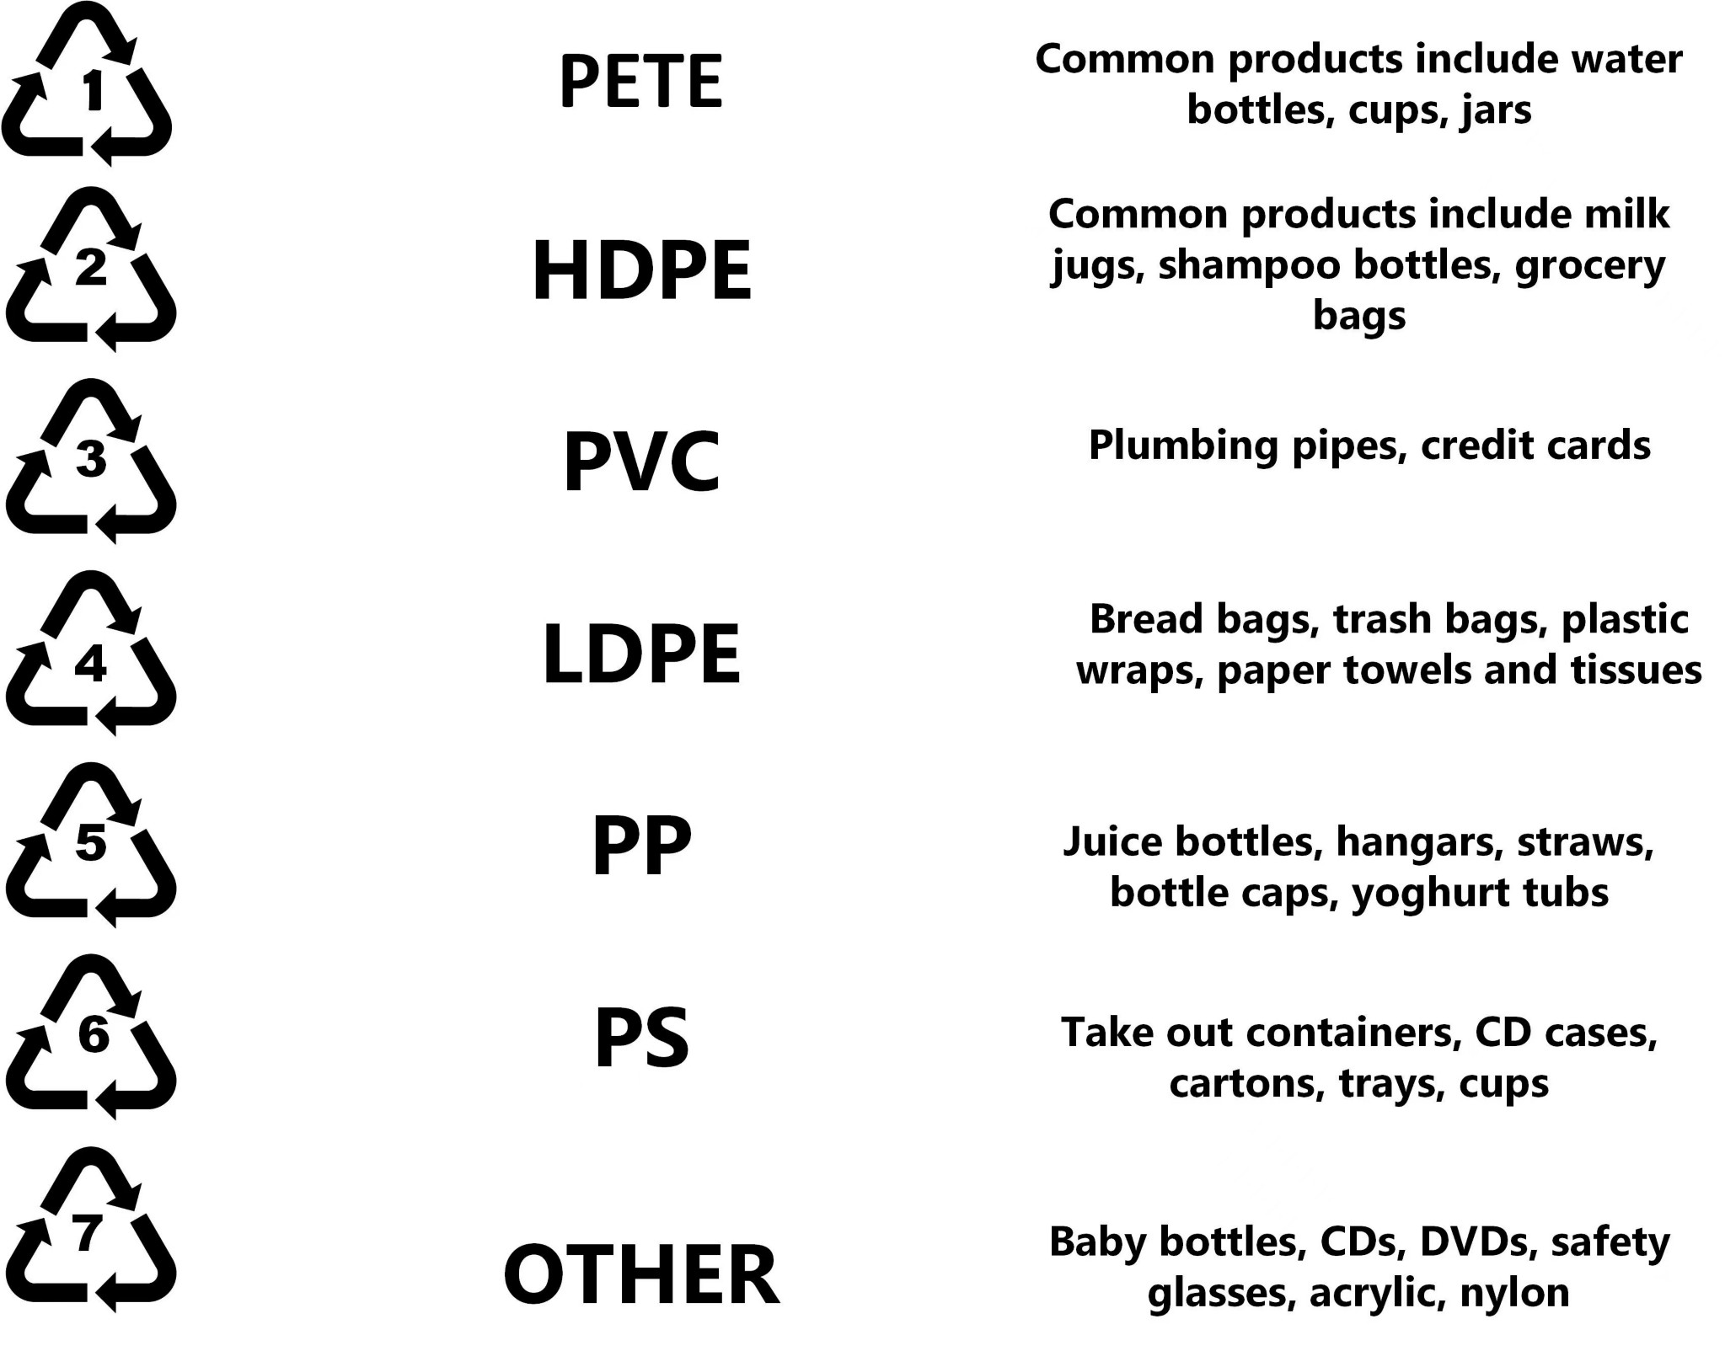Waste and the risks associated with it are becoming an increasingly serious problem in environmental protection. There is an expanding interest in waste management in the world, in both the development of technologies to minimize their quantity and those related to their disposal and economic use. The main reason for extreme waste generation is irrational materials management. The garbage gather in landfills may be used as secondary raw materials, the value of which is estimated at a couple hundred million dollars. 25% of this amount is coal; 35% is zinc, lead, iron, and other metals; and 40% is related to components such as ash, slag, rock waste, aggregates, and others [1].

Use this template in your own intelligent garbage classification using deep learning sessions so your team can unleash their imagination and start shaping concepts .

Reference: <https://rme.cbr.net.pl/index.php/archiwum-rme/13-nr-42/ekologia-i-srodowisko/12-problemy-gospodarki-odpadami-w-polsce>

**Step-1: Team Gathering, Collaboration and Select the Problem Statement**

When designing the structure of a neural network, the first step is fixing the size of the input image. High-resolution results increase in the number and time of calculations, which in turn may lead to overloading of the computational units and their memory.

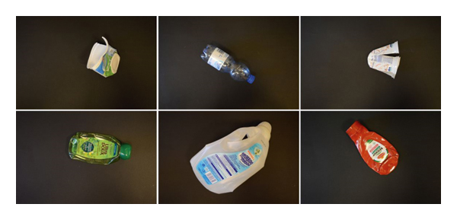

**Step-2: intelligent garbage classification , of idea 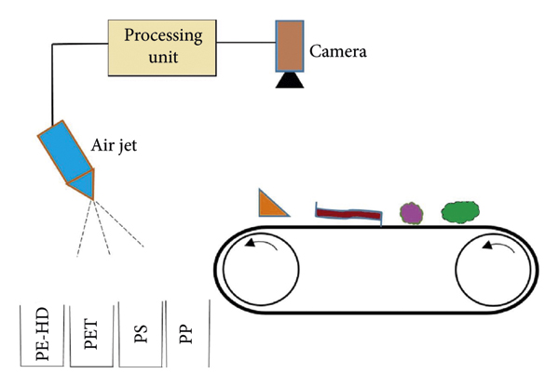lisenting and Grouping:**

**Step-3: Idea Prioritization:**

**The proposed system is tested on the trash image dataset which was developed by Gary Thung and Mindy Yang, and is able to achieve an accuracy of 87% on the dataset. The separation process of the waste will be faster and intelligent using the proposed waste material classification system without or reducing human.**

Refference : https://www.niehs.nih.gov/health/materials/cancer_and_the_environment_508.pdf.